Steps for entering physical counts.

(Use this method to update the book to the physical – this allows you to do the additions and subtraction from the existing inventory in Advantzware.)

- Run menu hot keys N-F-10 to rebuild warehouse and bin locations.
Click Options to delete negative bin locations and zero balance bin locations.
- Run menu hot keys I-C-1 physical count report
- Plant personnel to hand write actual inventory counts on physical count report by item, job#, warehouse & bin
- Menu hot keys I-C-2
Office personnel to enter actual inventory counts on physical count report
by item, job#, warehouse & bin. Please note, the count date must be entered on each record.
Please note, If inventory by plant was counted on Saturday, but office is entering the counts into the computer
on Monday, then change the computer date to Saturday so each record defaults to correct date.
5) Post Inventory via I-C-3.
Please note when adding physical counts, the F1 key on the tag# field will display all jobs and locations for this item. The buttons at the bottom of the popup window allow selecting all item and importing all locations as zero on hand or importing the existing quantity on hand. Therefore, only the quantities need to be entered rather than typing each line for each job and location.

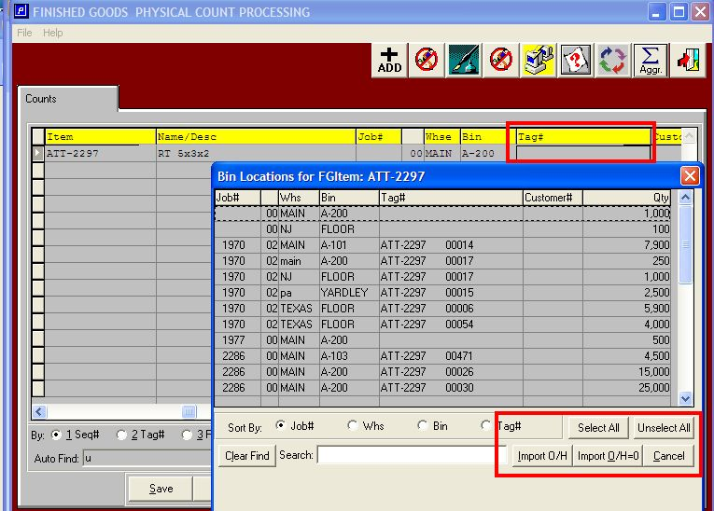

6) Run N-F-10 again so that the system can post any receipts or shipments that happened since the inventory was input.

